Network Architecture and Protocol Lab

Booklet 4
Submitted by: Jamil Ahmed
Neptun Code: JZT75Y

4.1
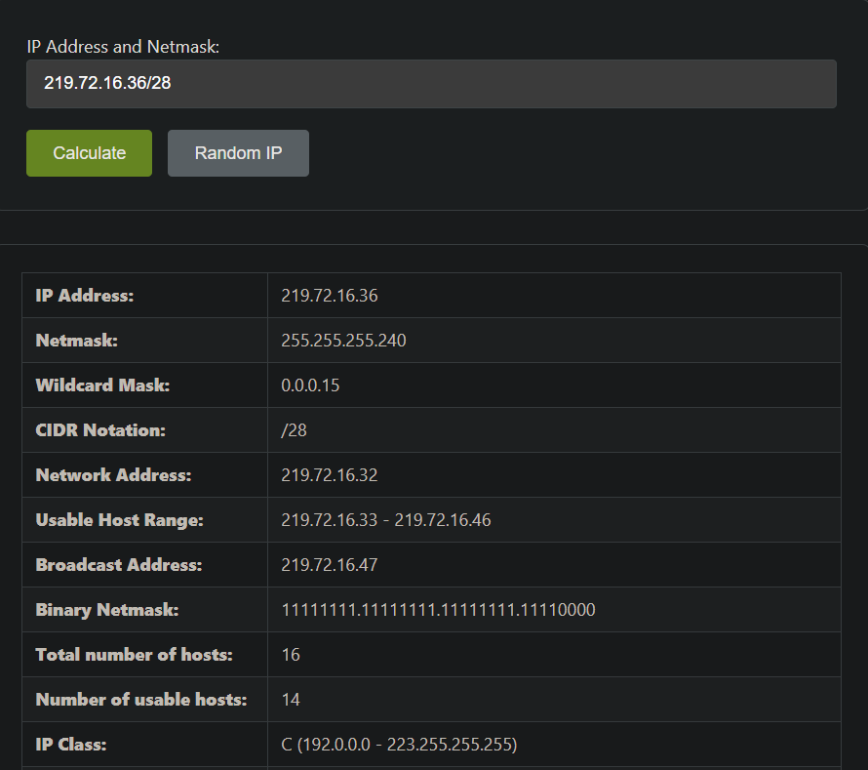
A) Network address / NetID: 219.72.16.36
B) Host address / HostID: 219.72.16.33 - 219.72.16.46
Host ID: 4
C) IP address class: Class C
D) Netmask:
Slash notation: /28
Dotted decimal: 255.255.255.240

4.2
A) IP addresses of VMs:
VM1: 10.0.0.1/8
VM2: 10.0.0.2/8
VM3: 10.0.0.3/8
B) Changing IP of 1st machine:
sudo ip addr flush dev eth0
sudo ip addr add 219.72.16.36/28 dev eth0
sudo ip link set eth0 up

4.3
A) Physical address:
MAC Address: 08:00:27:41:50:55
Command: ifconfig
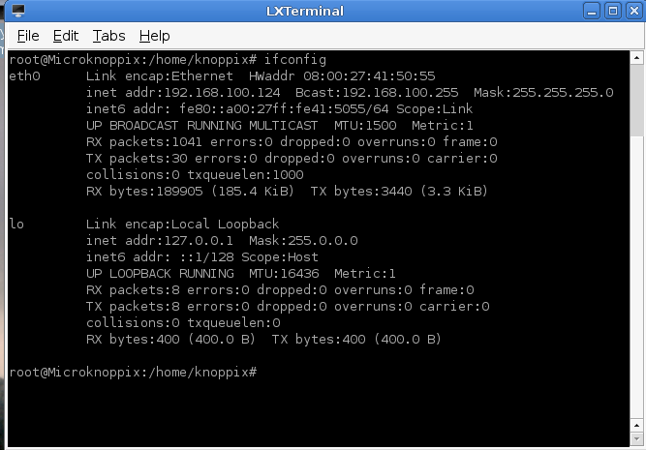

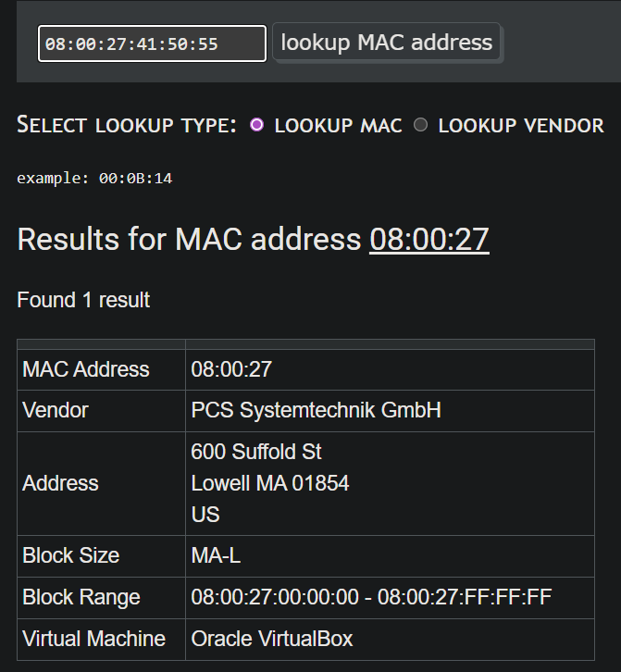
B) Manufacturer:
PCS Systemtechnik GmbH

C) ARP table behavior:
After disconnecting, entries remain temporarily but become invalid. After reconnection and ping, the table refreshes.

D) Insert ARP entry:
sudo arp -s [IP_address] [MAC_address]

E) Delete ARP entry:
sudo arp -d [IP_address]

4.4
A.
 |  | Source | Destination
(3) | IP | 128.119.199.43 | 128.119.248.227
 | MAC | 89-D9-AC-73-20-EF | 6D-14-64-A8-8B-4D
(2) | IP | 128.119.199.43 | 128.119.248.227
 | MAC | 92-52-31-C4-F5-35 | 0F-D9-69-AC-C3-70
(1) | IP | 128.119.199.43 | 128.119.248.227
 | MAC | 92-52-31-C4-F5-35 | 0F-D9-69-AC-C3-70

B.
The IP address is used for identifying the source and destination devices across different networks (end-to-end communication).
The MAC address is used for communication within a local network and changes at each step (device to device).
IP is used for routing (logical addressing) and MAC is used for delivery within the local network (physical addressing).

